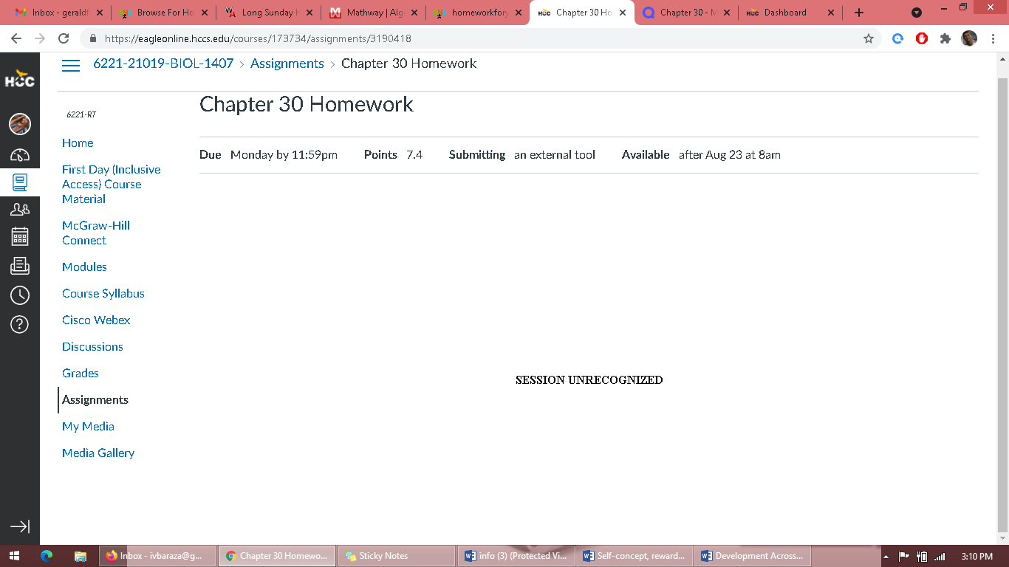
THE ABOVE IS THE MESSAGE FROM OUR CHAPTER 30 HOMEWORK. I WAS NOT ABLE TO COMPLETE IT. THANKS!

